1. The start of application

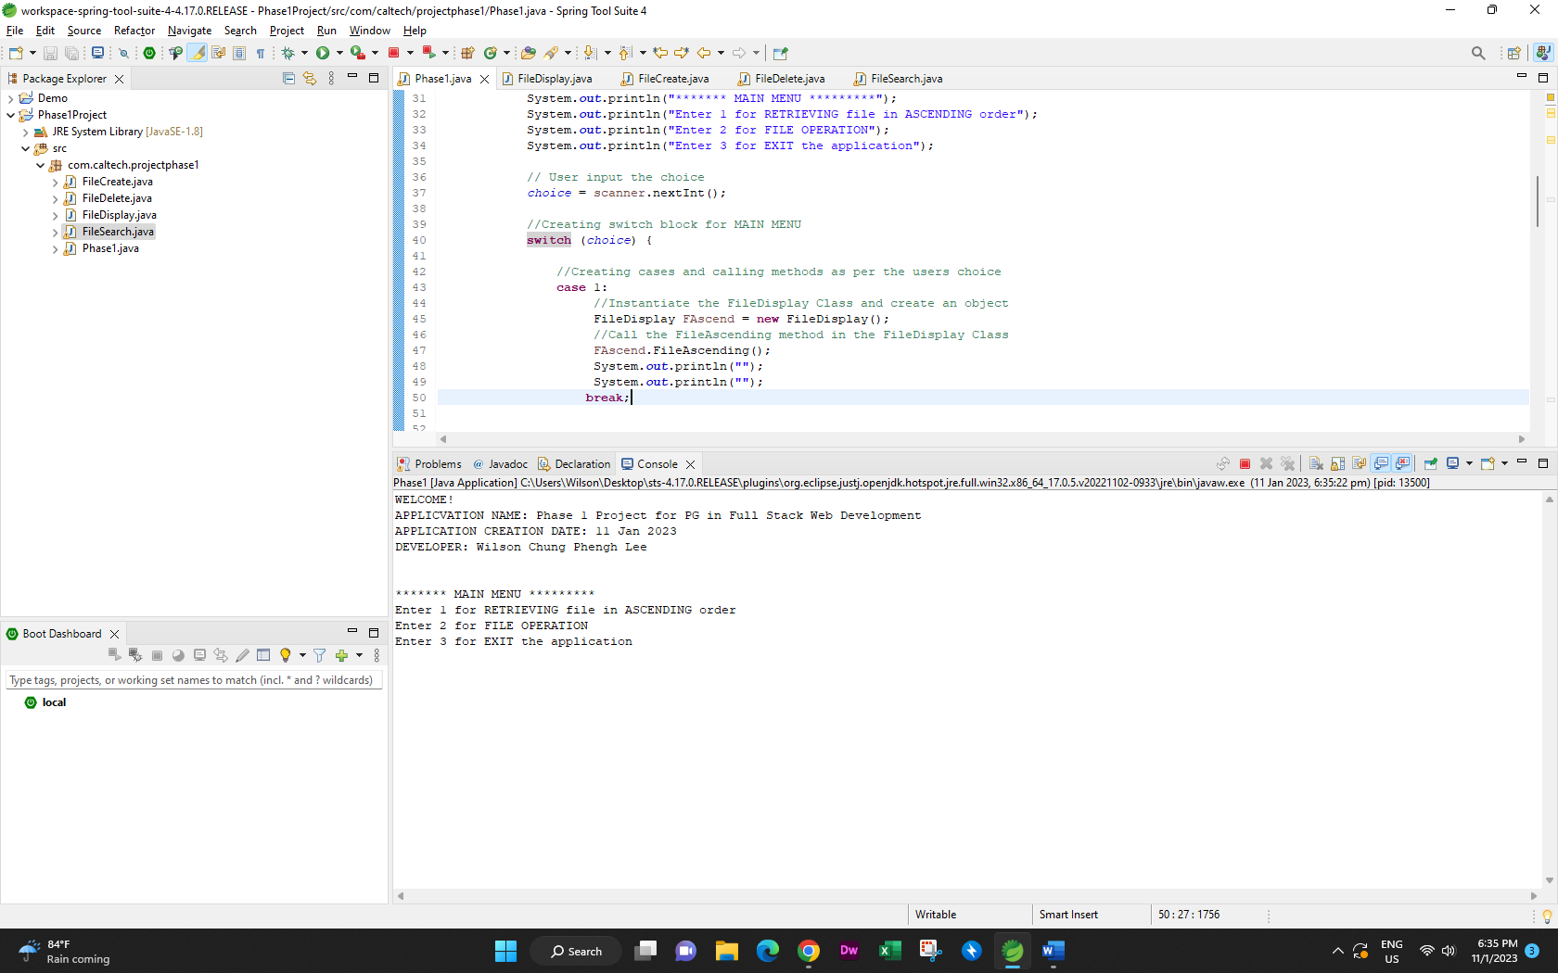

1. Select item other than 1 or 2 or 3

The system prompt the user: “You have entered the wrong choice”

The Main Menu reappear again.

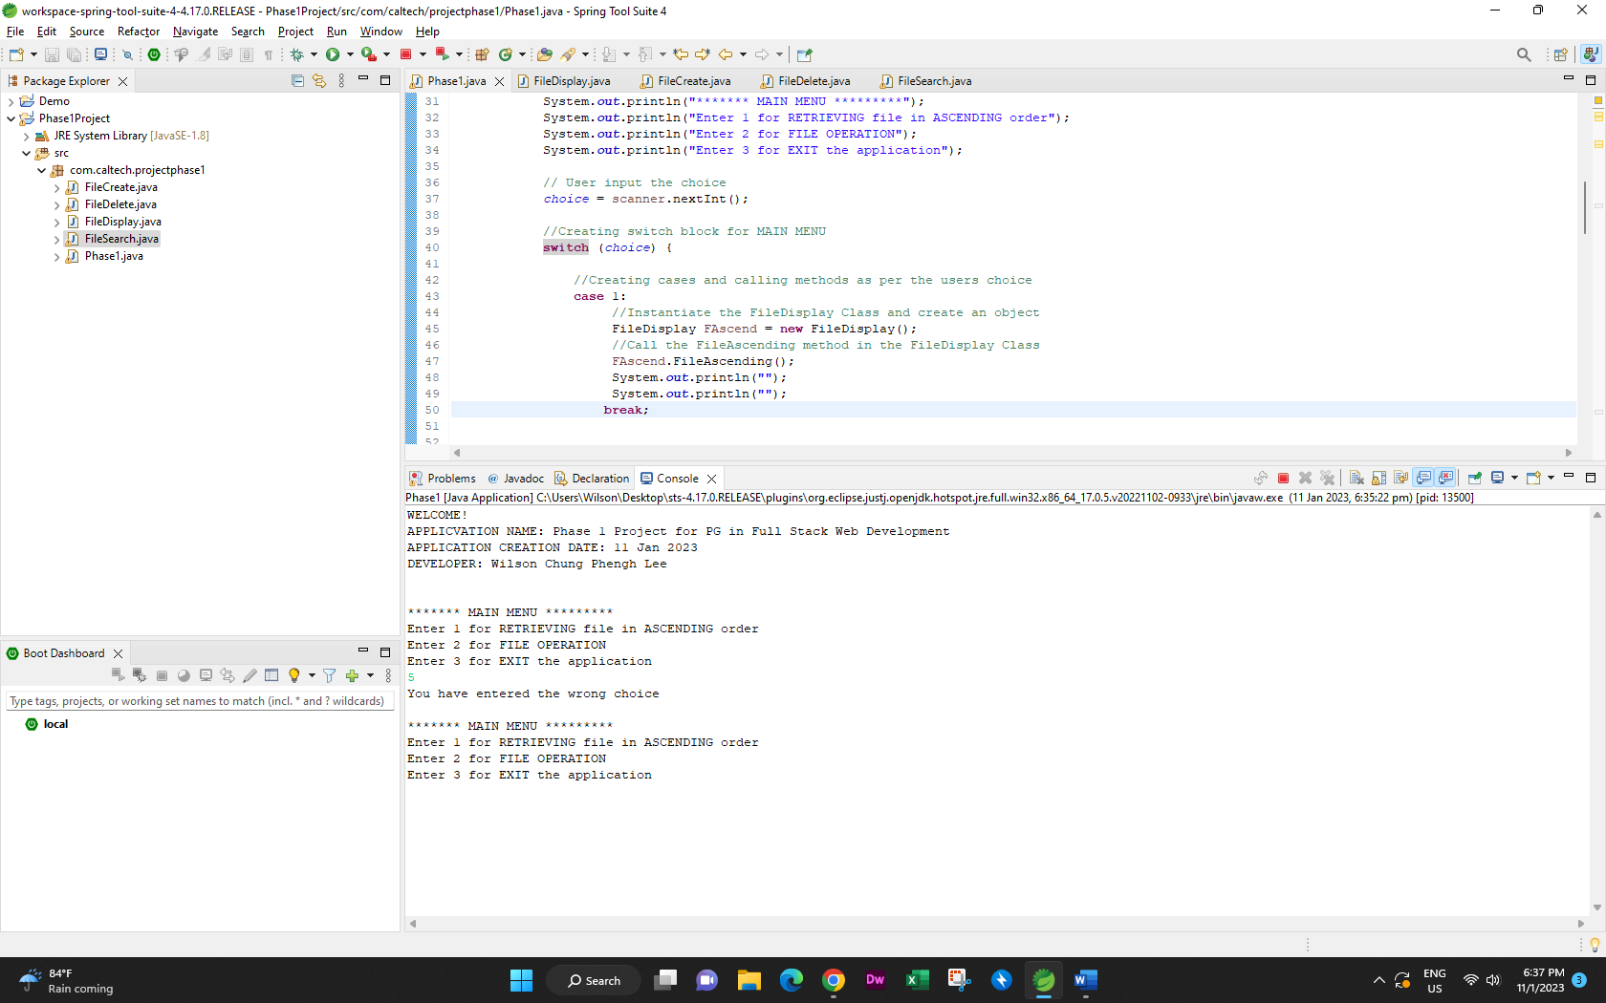

1. Select item 1 for RETRIEVING file in ASCENDING order

In case, the directory has files

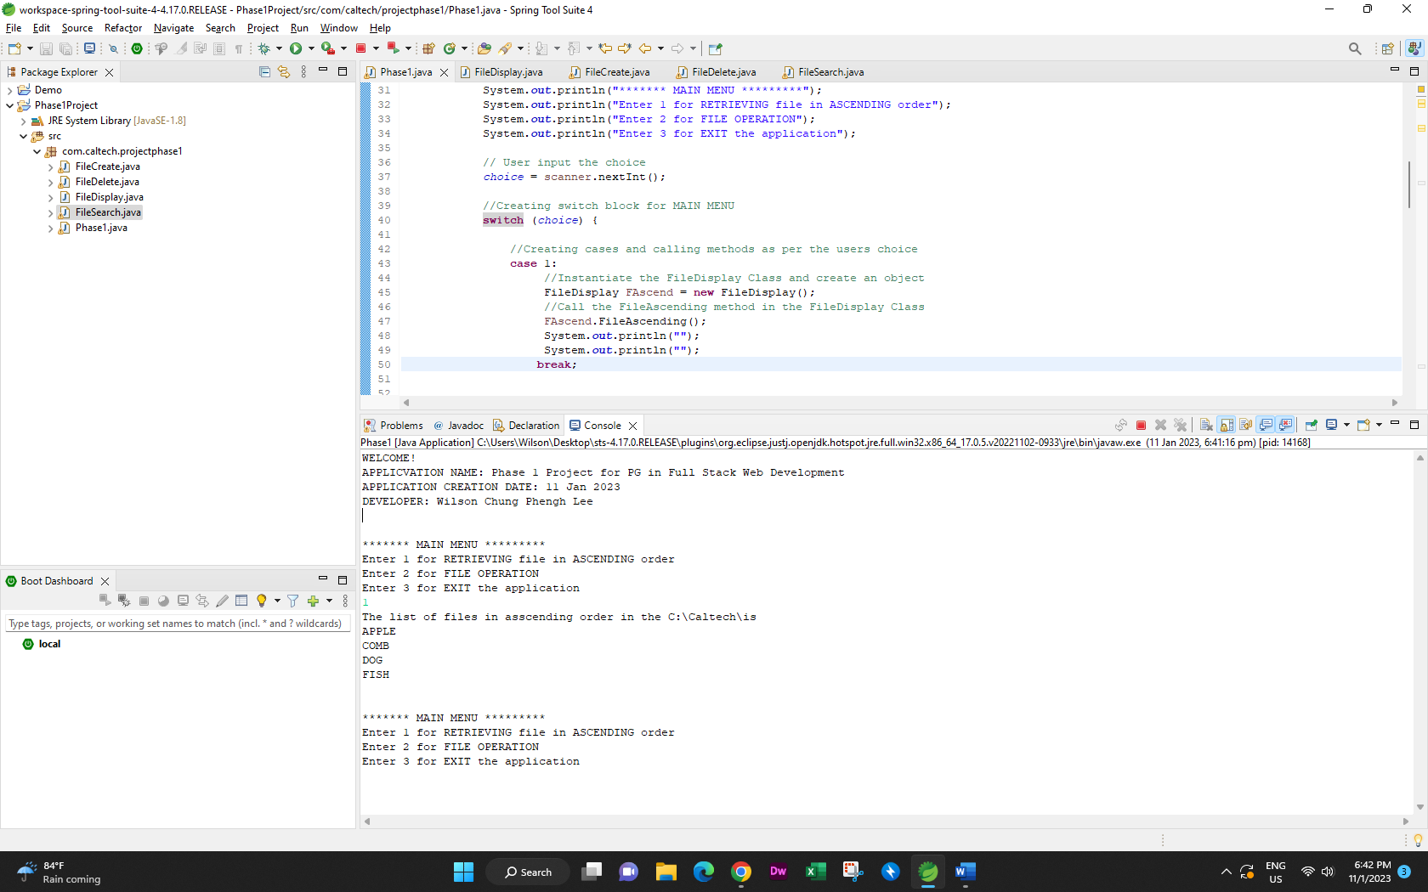

In case, the directory does NOT has file in it.

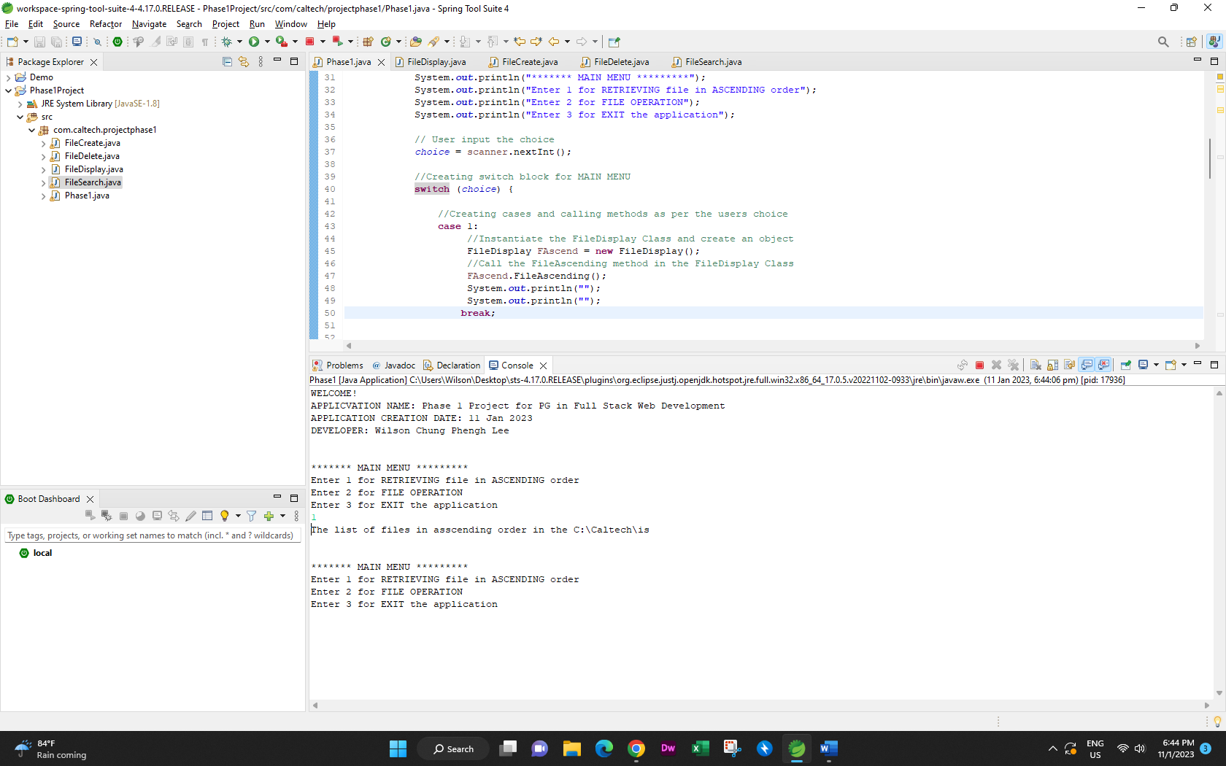

1. Select Item 2

Sub Menu appear

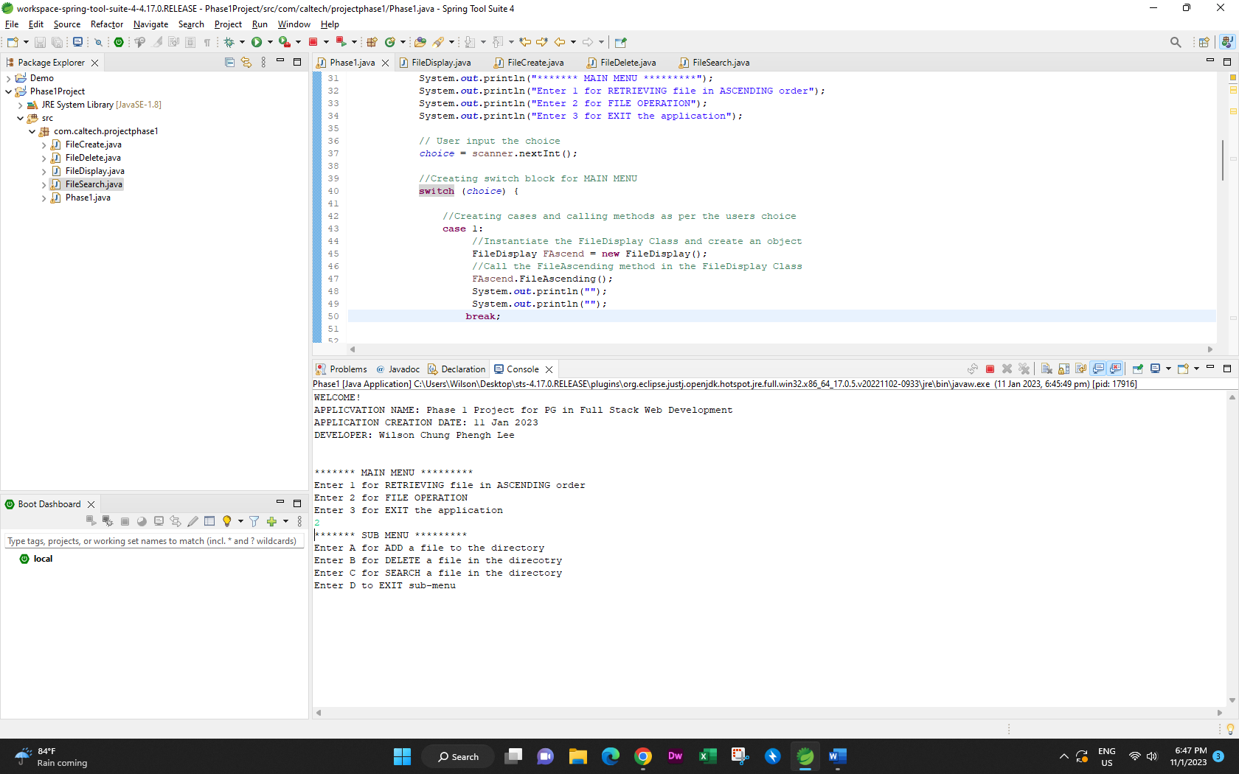

1. Select item 3

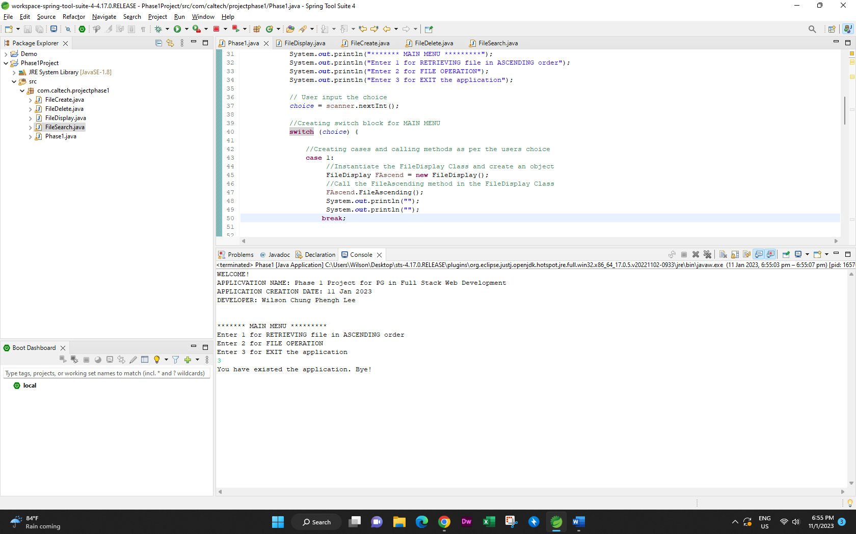

1. Select Sub Menu Item other than A or B or C or D

The system prompt the user:

You have entered the wrong choice

Please enter A or B or C or D

Main Menu is re-appear gain.

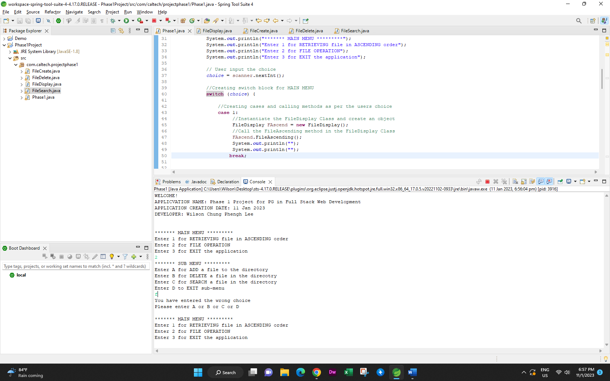

1. Select Sub Menu Item A

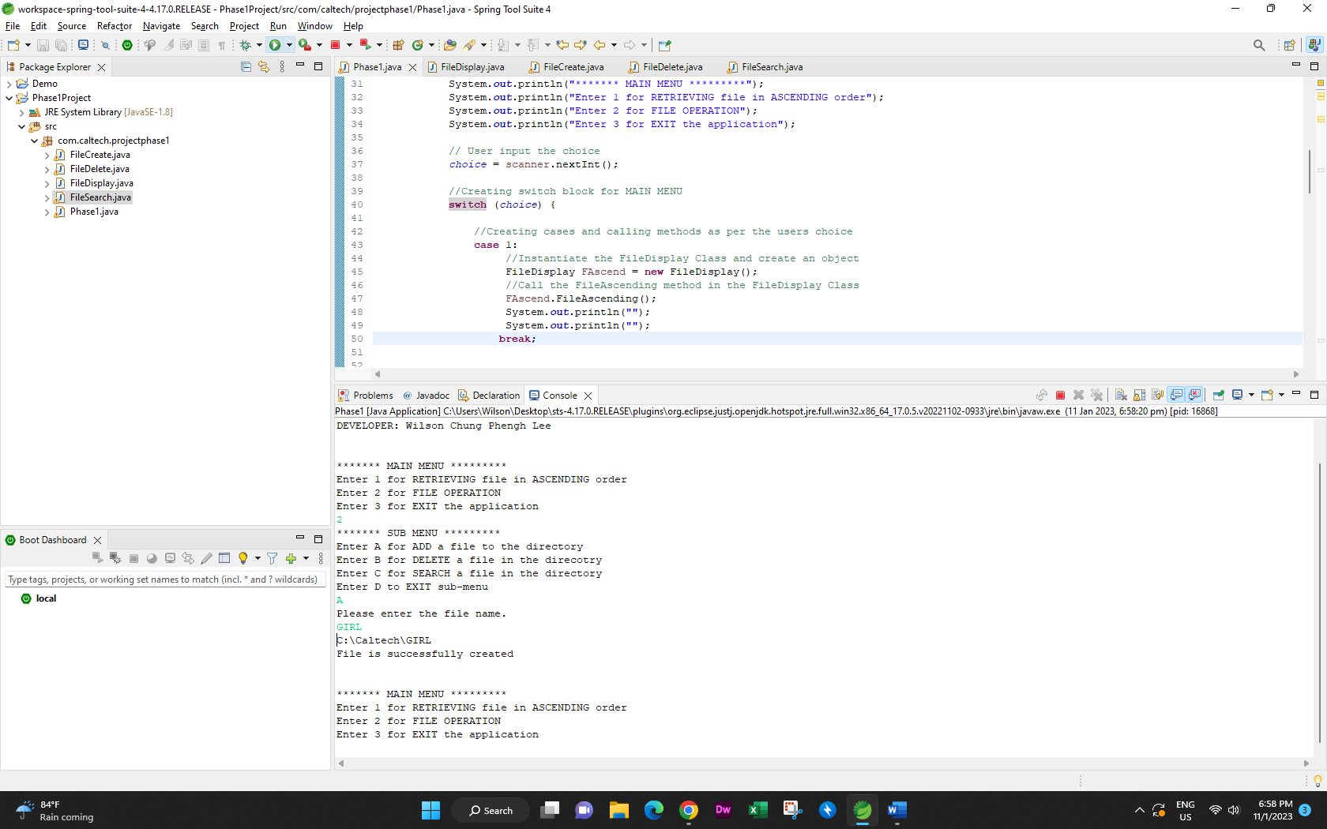

1. Select Sub Menu Item B

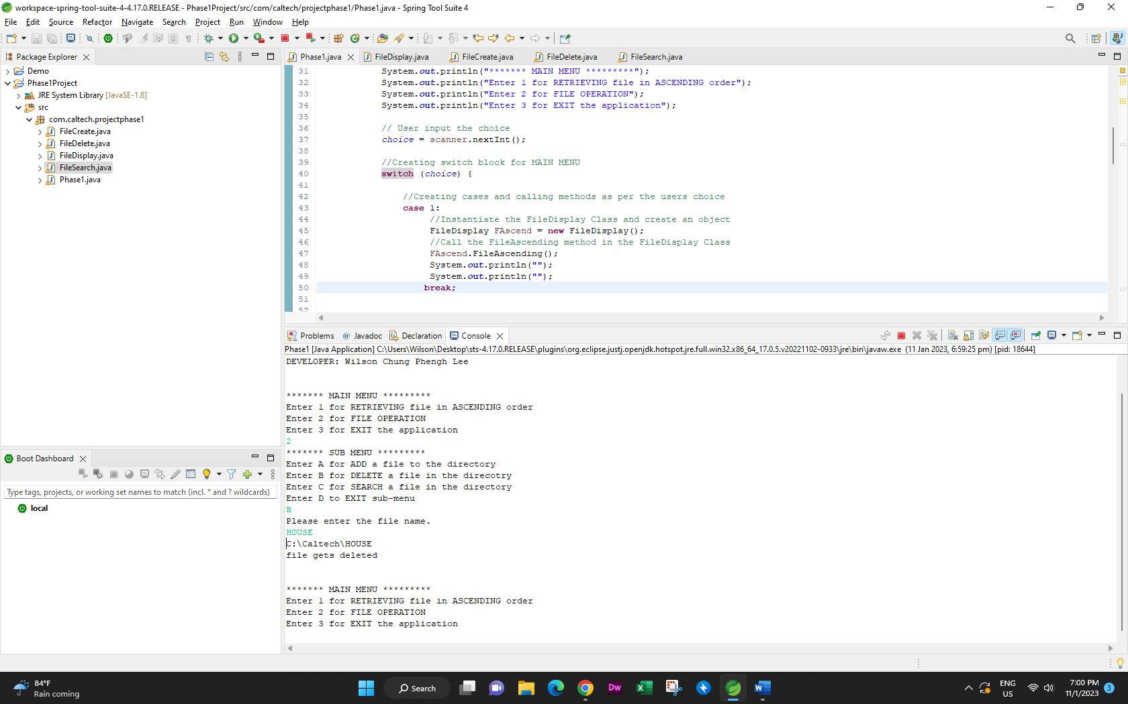

1. Select Sub Menu Item C

In case file is not in the directory

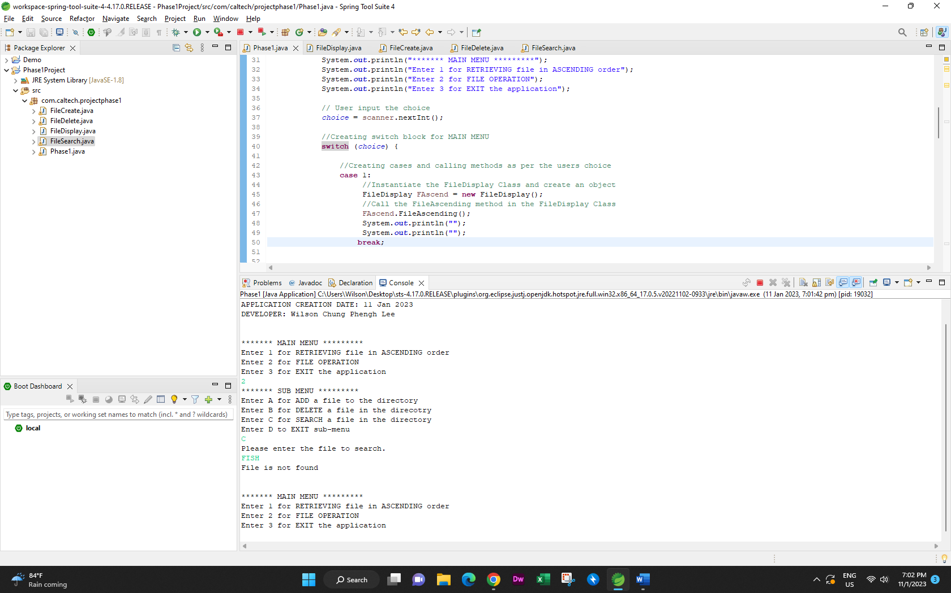

In case file is in the directory

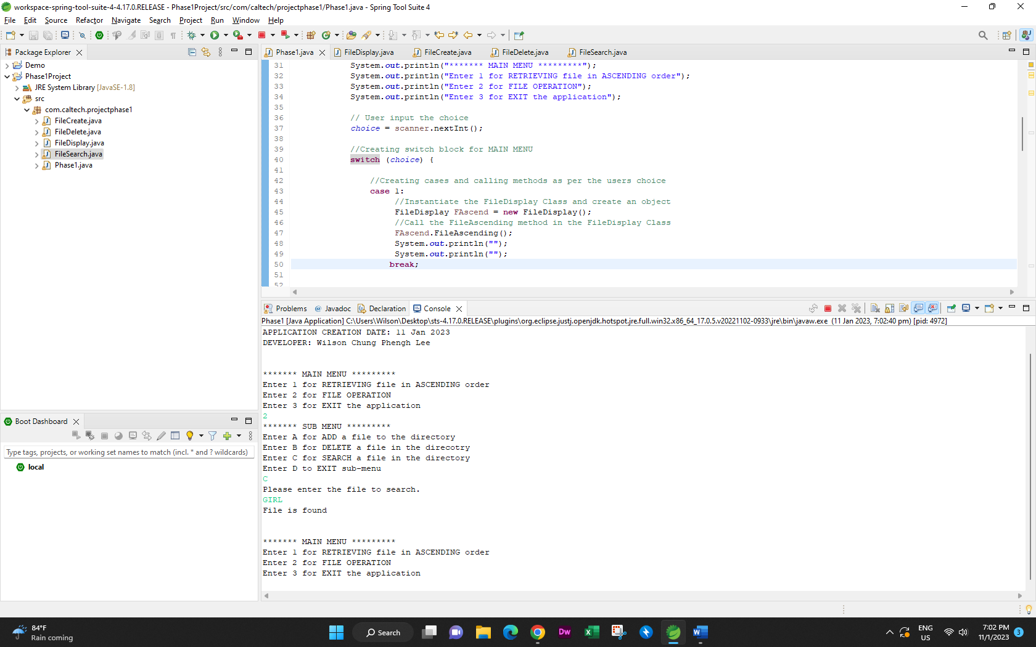

1. Select Sub Menu Item D

System goes back to Main menu

